Ideation Phase
Brainstorm & Idea Prioritization Template

Project Name | Snack Squad: A Customizable Snack Ordering and Delivery App
Maximum Marks | 4 Marks

Brainstorm & Idea Prioritization Template:
Reference: https://www.mural.co/templates/empathy-map-canvas
Step-1: Team Gathering, Collaboration and Select the Problem Statement
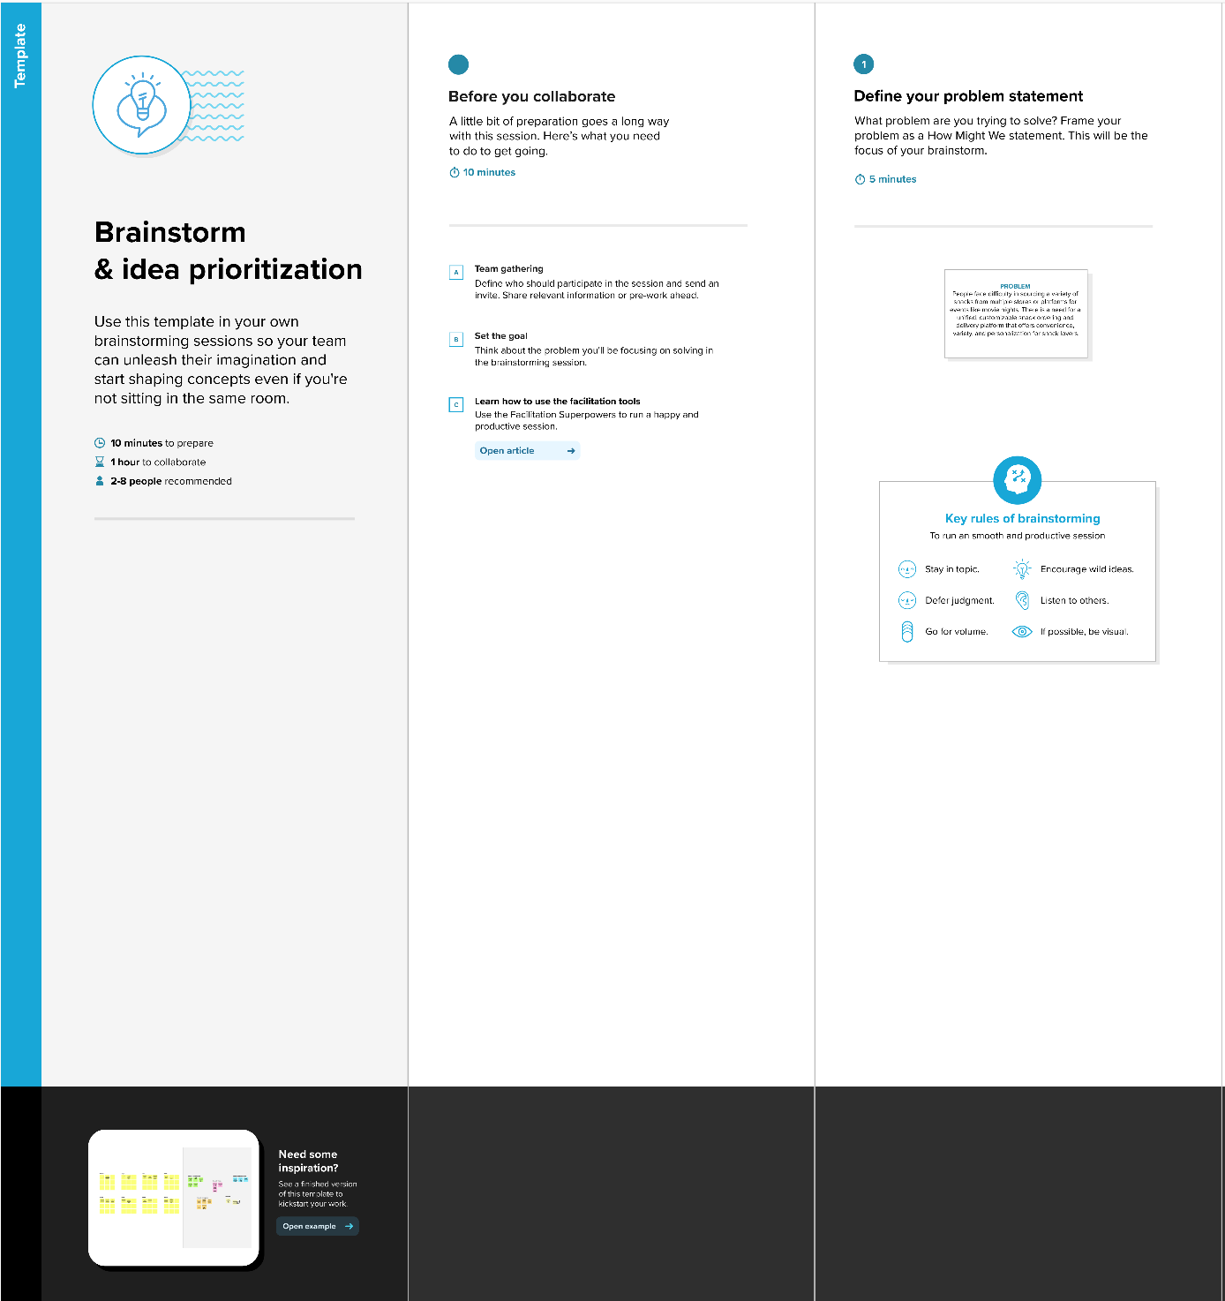

Step-2: Brainstorm, Idea Listing and Grouping
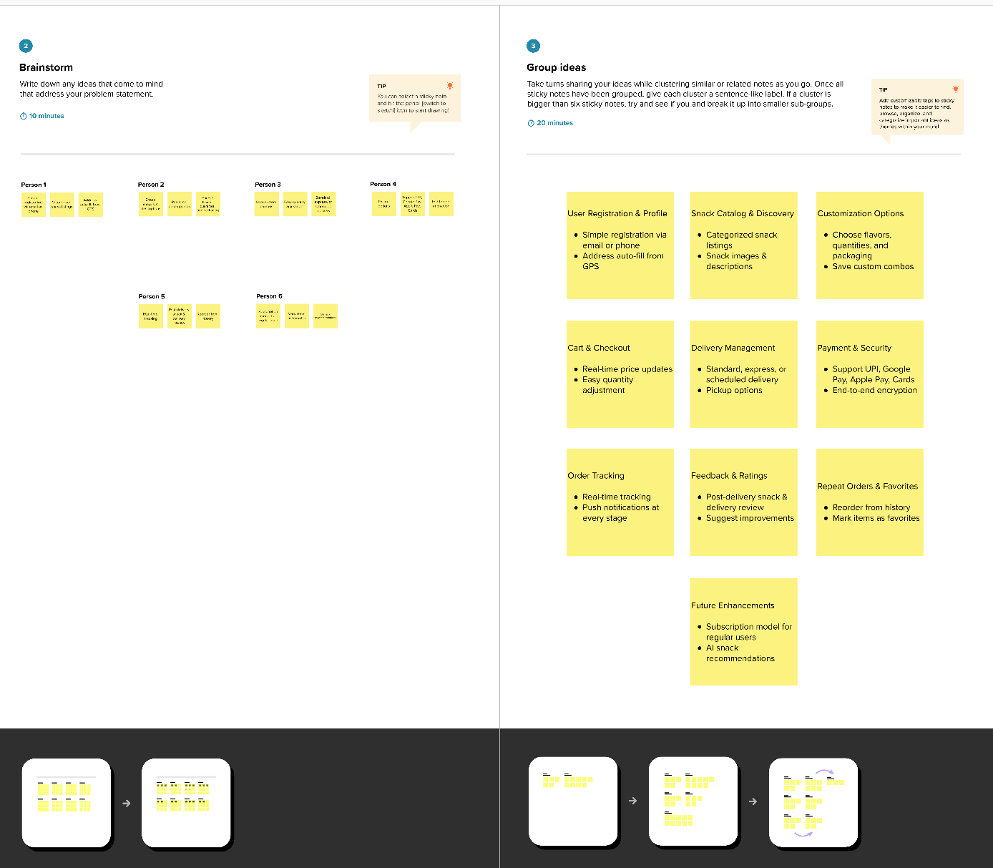

Step-3: Idea Prioritization
